|  |  |
| --- | --- |
| PROJECT Design  Week 4 Assignment | ABSTRACT  This document was created for UMUC Course, CMSC 495, and analyzes aspects of the (TNC)  Group 3 Members  Name: Christiano, Andrew  Name: Fernandez, Yrume  Name: Orwick, Brian  Name: Sell, Julia  Class: CMSC 495 - Current Trends and Projects in Computer Science Professor: Dr. Hung Dao  Due: 16 September 2018 |

**Version Control**

|  |  |  |  |  |
| --- | --- | --- | --- | --- |
| Revision # | Date | Name | Descriptions | Contact Info |
| TNC_0001 | 9/13/2018 | Brian Orwick | Created | Orwick12@outlook.com |
|  |  |  |  |  |
|  |  |  |  |  |
|  |  |  |  |  |
|  |  |  |  |  |

**Class Diagram**

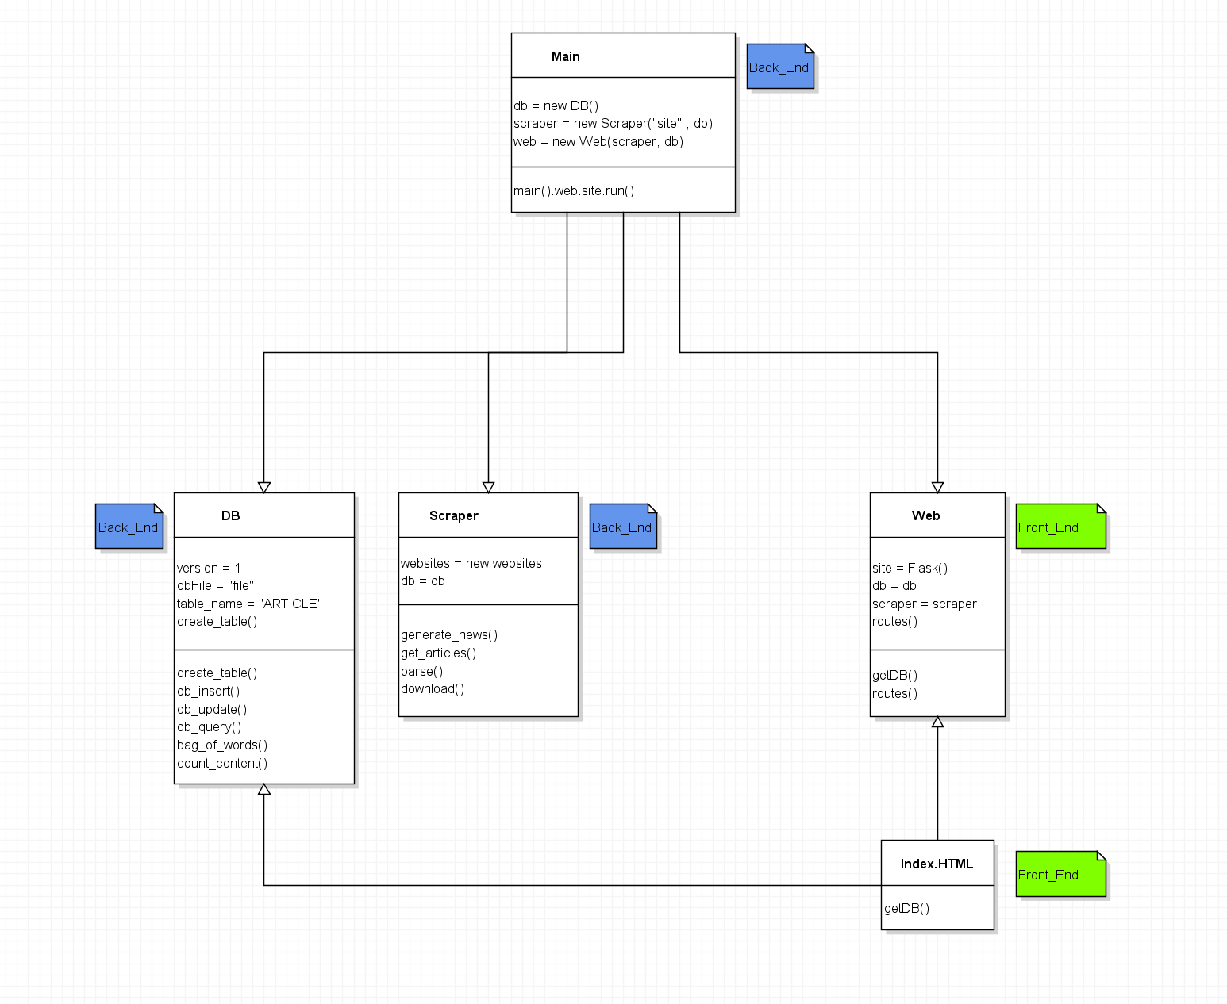

*Figure 1 – Class Diagram*

Did not do subsystems just included classes and Index.html.

**Event Trace (or sequence) diagram**

**Scenario 1: (startup, normal run, error handling)**

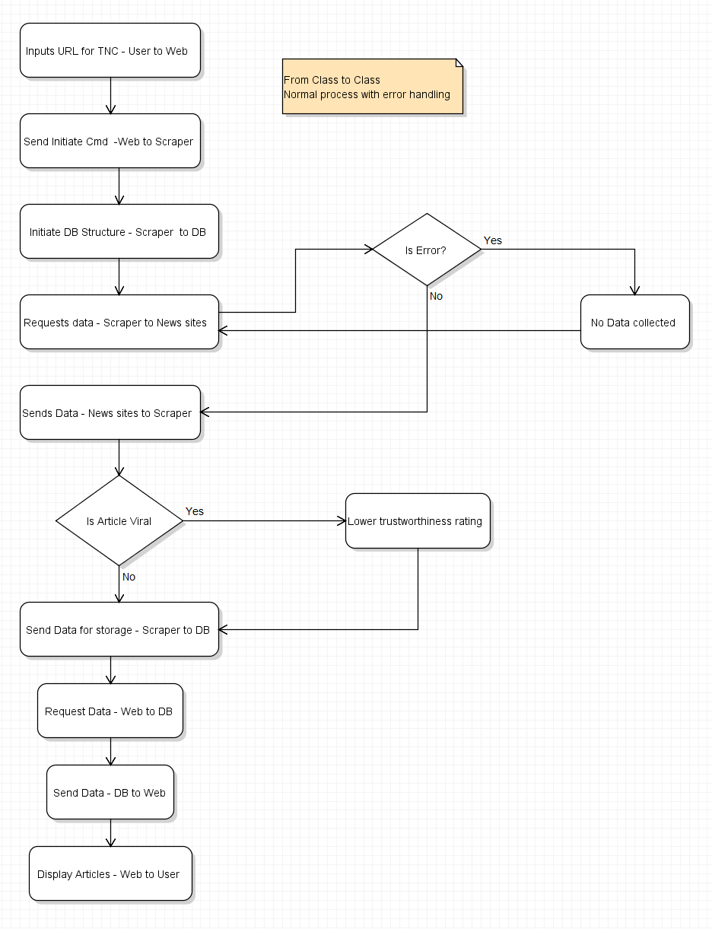

**Scenario 2:**

shut-down early diagram

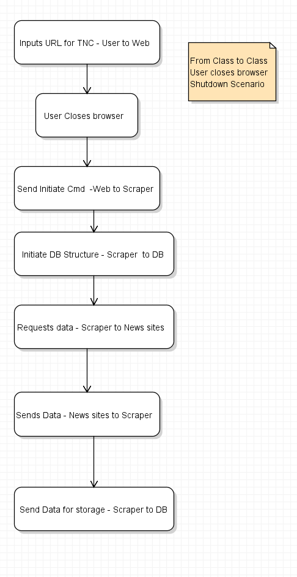

**Scenario 3:**

???

**Pseudocode**

**Front End**

**Web class**

routes()

initialize TNC website

getDB()

Generate news with scraper.generate_news()

Request data from DB with db.DB_query()

**Back End**

**Main Class**

Import db, scraper, web

Main().web.site.run()

**Scraper Class**

Import newspaper

generate_news()

get_articles()

parse(articles)

get_articles()

paper = newspaper.source(website)

paper.download()

paper.parse()

paper.categorize()

parse(articles)

for article in articles

download(article)

db.DB_insert(url, date, content)

download(articles)

article.download()

article.parse()

return (url, date, content)

**Data Base**

**DB Class**

create_table()

open db

if table is exists

assign as current table

else

create new table

db_insert(url, date, content)

open db

insert(url, date, content)

db_update(id, qualifier, input)

open db

find id and qualifier

insert input

db_query()

bag_of_words()

json []

open db

for row in db

append json[]

html = “<html>”

html += Dump json[]

html += “</html>”

return html

bag_of_words()

open db

key_pair = {}

for row in db

key_pair = [count_content + id]

close db

open db

for k,v in key_pair.items()

update db

count_content(row)

content = row.split

dict([i, content.count(i)] for i in content)